# **analysing and visualizing trends in the nobel prize**

Himani Bansal1*, Bhartendu Dubey1

1Department of CSE/IT, Jaypee Institute of Information Technology, Noida, India

*Email: singal.himani@gmail.com

***Abstract***— As the researchers are working hard for making our lives better, their work needs to be acknowledged. In order to appreciate their immense contribution for serving humanity, The Nobel Prizes are being awarded. An Analysis of a century old Nobel prizes is presented by finding out the useful insights from The Nobel Data. Various factors such as age, country of origin, and motivational quotes were analysed to represent them in form of bar charts, scatter plots, box-plots, word cloud, and many more.

Keywords— Nobel Prize, Science, Data Analysis.

INTRODUCTION

The Nobel Foundation was established as a private institution in 1900, following the will of Alfred Nobel. The prime responsibility of this foundation is fulfilling the intentions in Alfred Nobel’s will. It led to the establishment of five Nobel Prizes. The main mission of the Nobel Foundation is to manage Alfred Nobel’s fortune in a manner that ensures a secure financial standing for the Nobel Prize.

The Nobel Prize is a set of annual international awards. They are bestowed in several categories by Swedish and Norwegian institutions in recognition of academic, cultural, or scientific advances around the world. They were first awarded in *Physics, Chemistry, Literature, Peace, Medicine* (or Physiology) in the year 1901. In 1968, a sixth category was also introduced for outstanding contribution in *Economics.* The Nobel Foundation also strives to safeguard the prize-awarding institutions’ common interests and to represent the Nobel organisation as a whole.

1. PAPER PRESENTATION

The Dataset was prepared by collecting information about all the Nobel laureates with help of Nobel Data API. The Dataset contains various factors such as gender, Birth Date, Birth city, Birth Country, category, Motivation quotes, associated organisation, etc.

These factors were analysed to gain the useful insights from the dataset. The Gender ratio was obtained from it as shown in fig.1. and fig.2. This was further analysed to obtain male:female ratio for different categories of the Nobel Prize as depicted in fig.3.

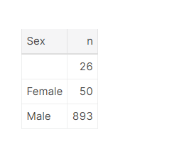

*Fig.1. Gender Ratio*

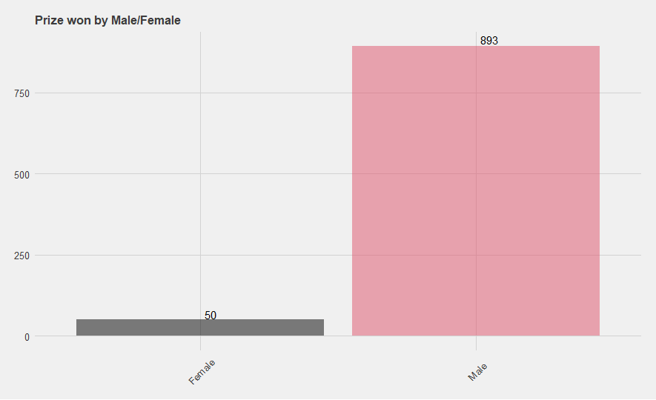

*Fig.2. Gender Ratio Plot*

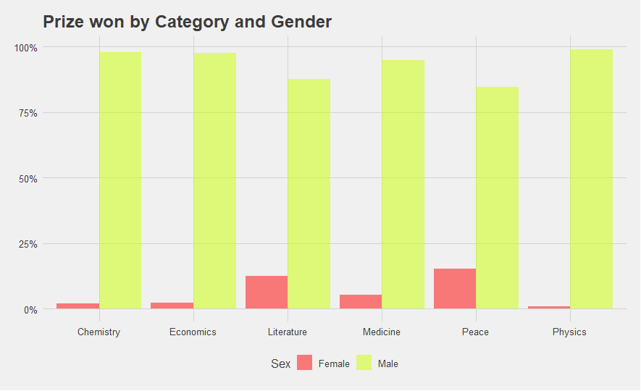

*Fig.3. Category vs Gender plot*

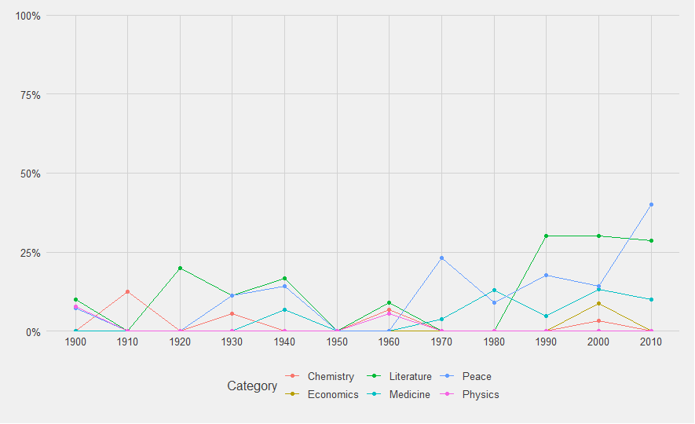

## Fig.4. Female Laureates Proportion per decade

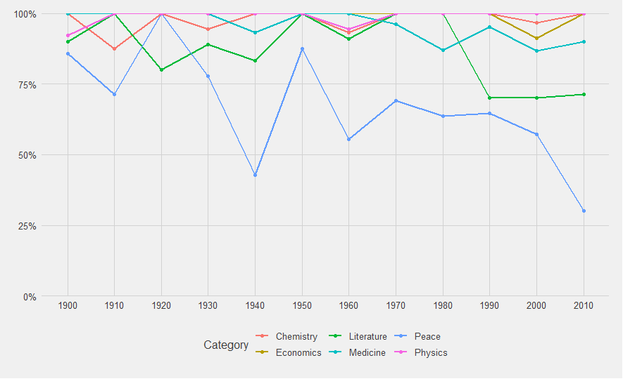

## Fig.5. Male Laureates Proportion per decade

* **#Category:**

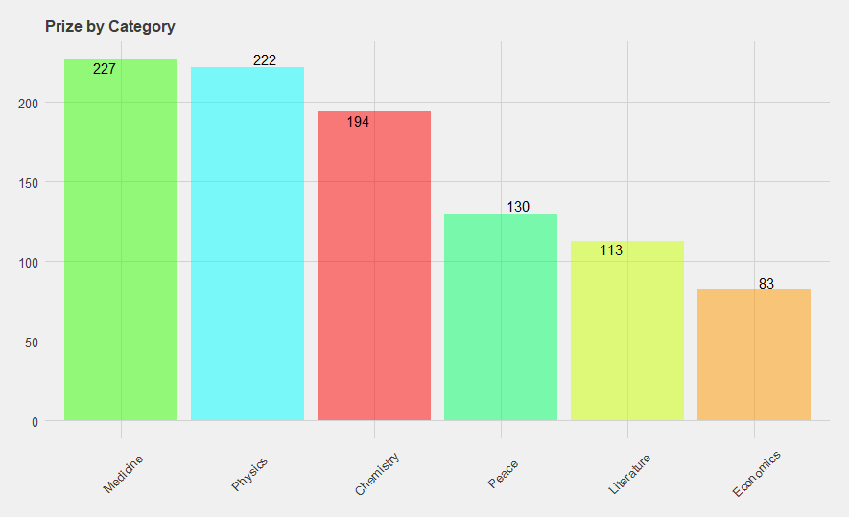

*Fig.9. Prizes by category*

* **#Sharing Prizes:**

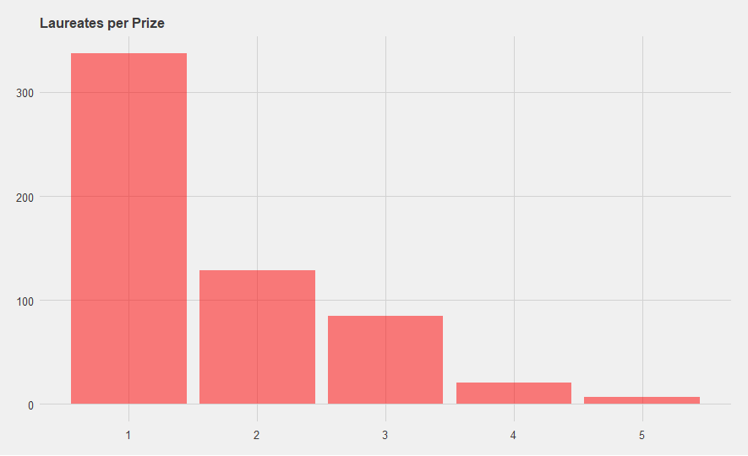

*Fig.10. Laureates count Per Prize*

* **#Multiple Nobel Laureates:**

Laureates/organizations may receive Nobel prize more than once, for their work in same or different field/topic.

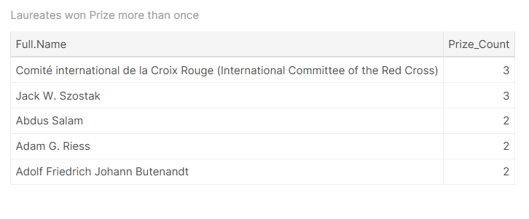

*Fig.11. Laureates with multiple Nobel Prizes*

* **#Age:**

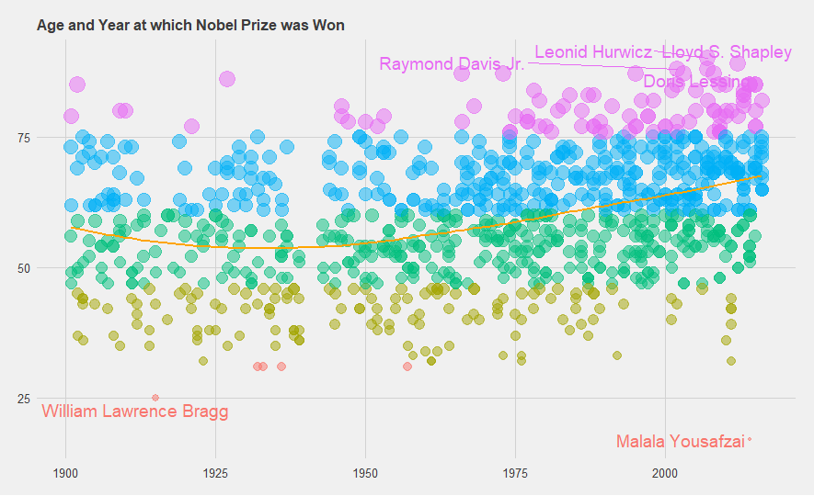

*Fig.12. Age vs Year of Nobel Prize Win*

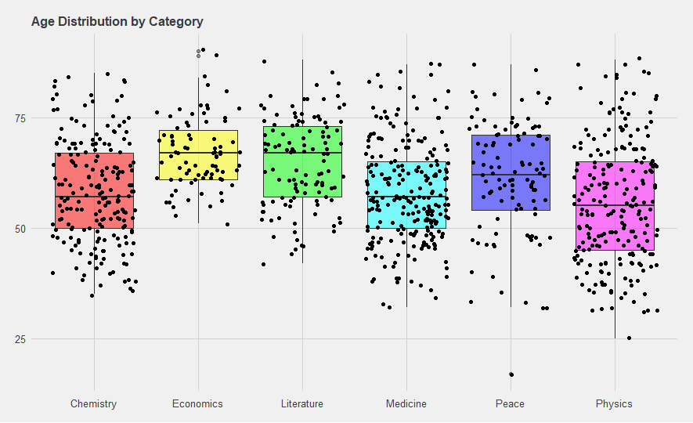

*Fig.13. Age Distribution by Category*

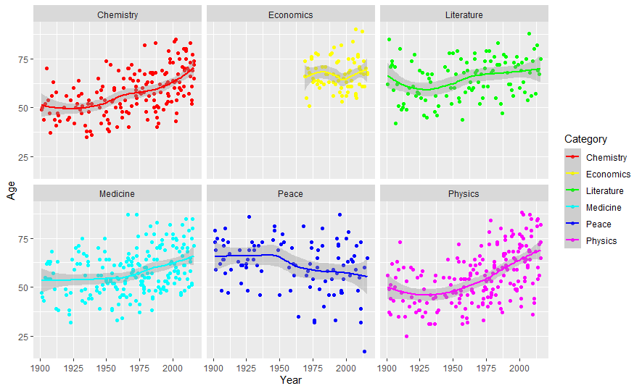

## Fig.14. Age Trend for receiving Nobel price per Category

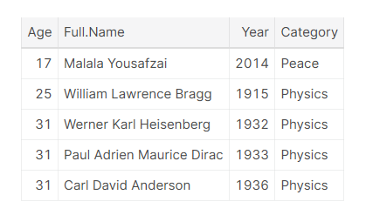

*Fig.15. Youngest Nobel laureates*

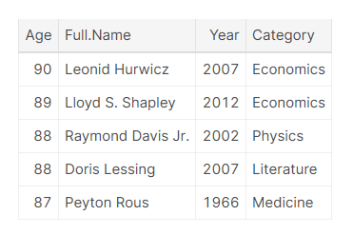

*Fig.16. Oldest Nobel laureates*

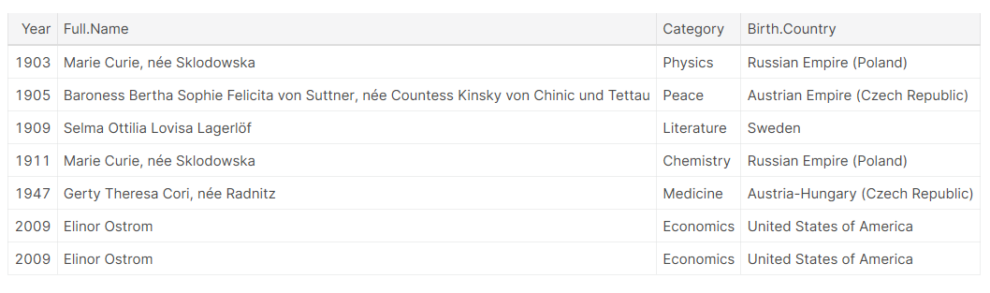

*Fig.17. First Female Laureate in each category*

* **#Life Span:**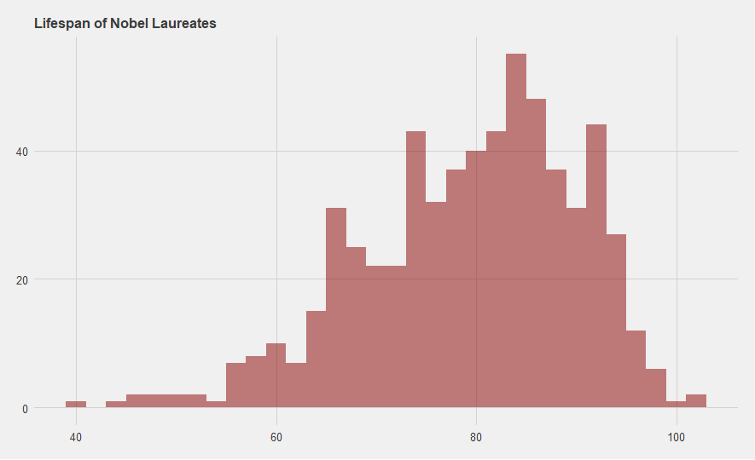

*Fig.18. Life Span of Nobel Laureates*

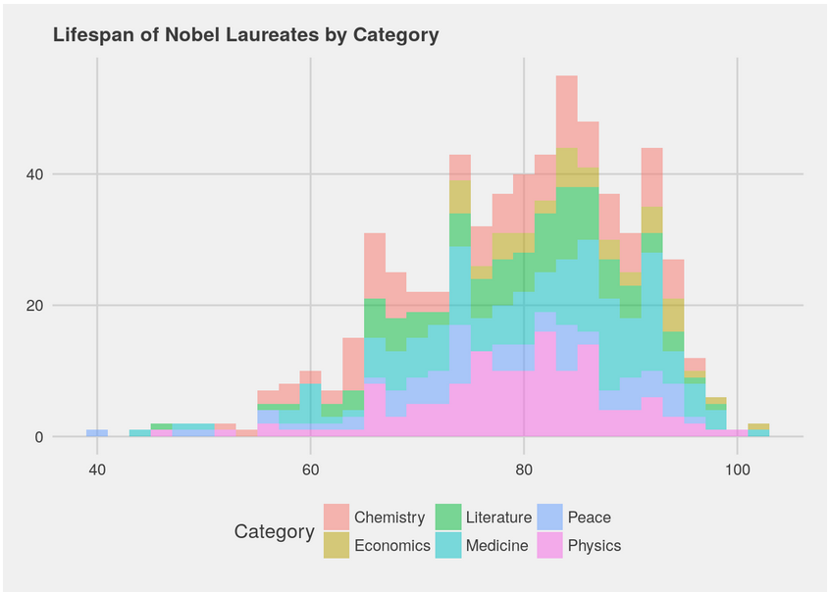

*Fig.19. Life Span By category*

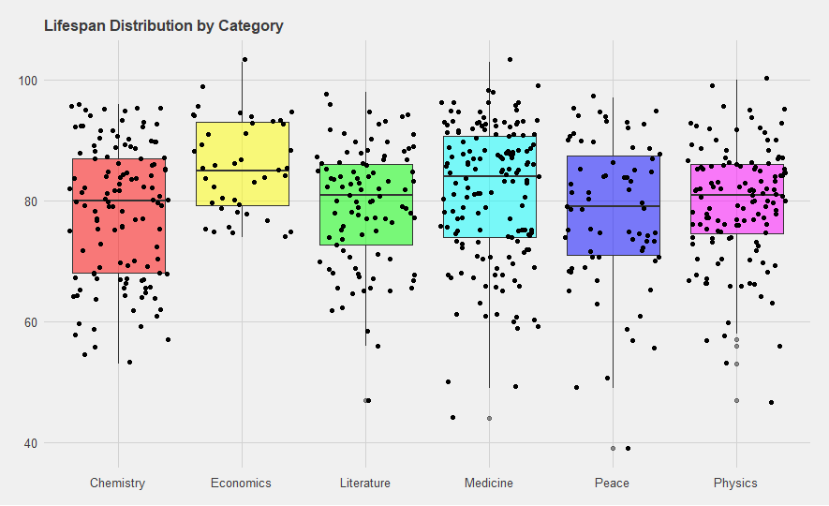

*Fig.20. LifeSpan Distribution by Category*

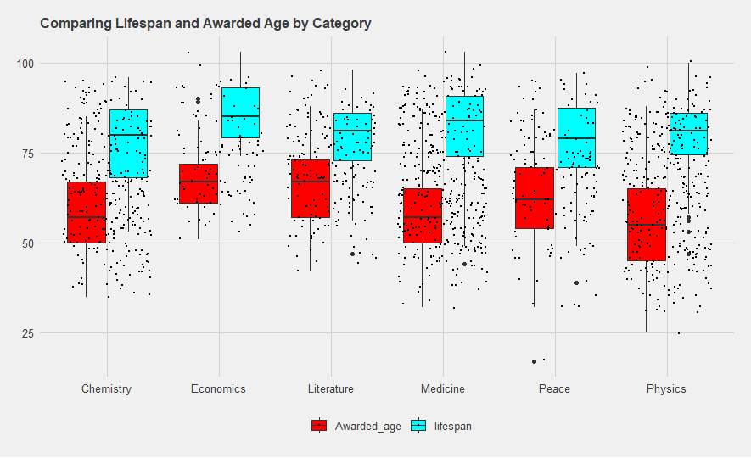

*Fig.21. LifeSpan Vs Awarded age*

* **#Country:**

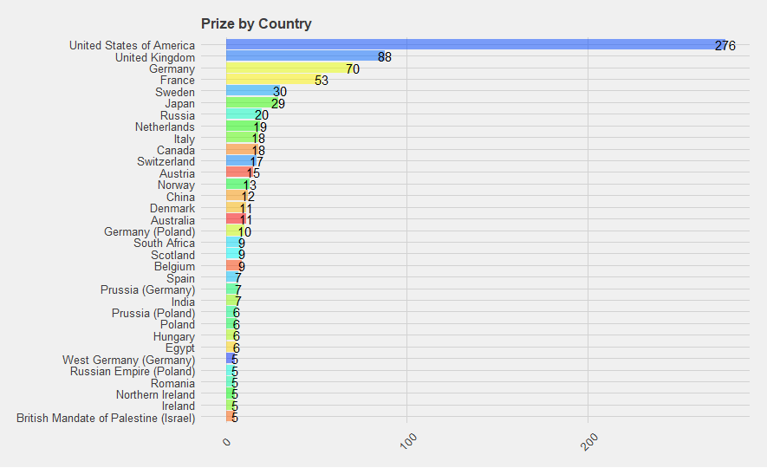

*Fig.22. Prizes by country*

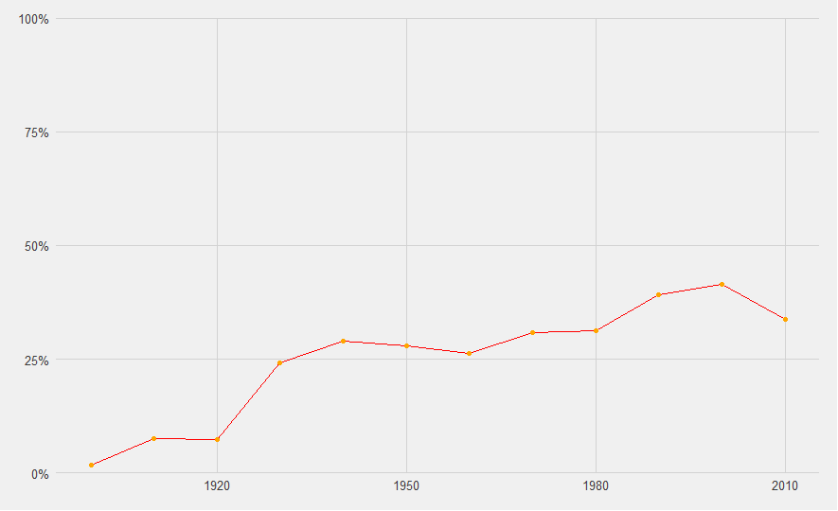

*Fig.23. USA-Year wise proportion*

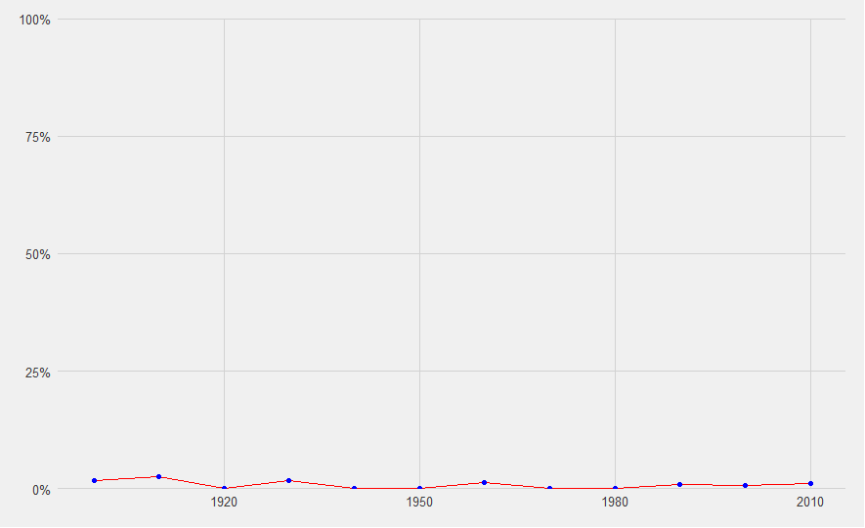

*Fig.24. India-Year wise proportion*

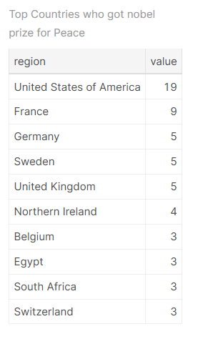

*Fig.25. Peace Laureates by Birth Country*

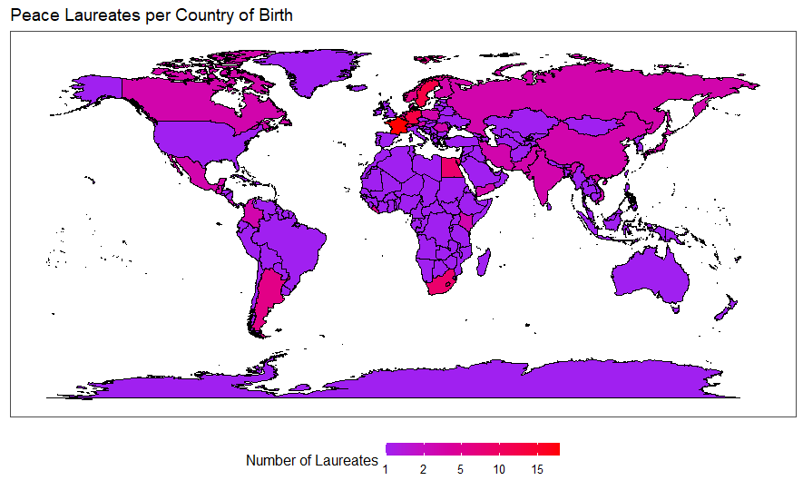

*Fig.26. Peace Laureates country map*

* **#Finding Prize Motivation:**

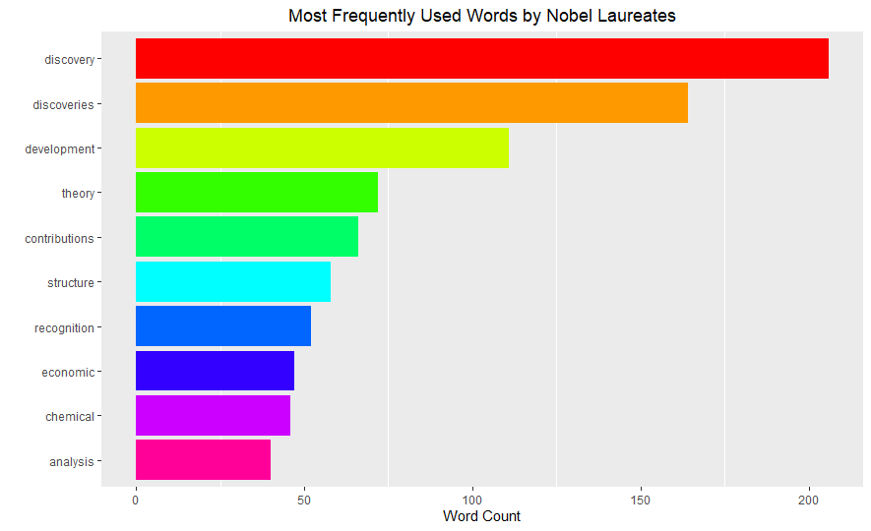

*Fig.27. Most frequently used words by Nobel laureates*

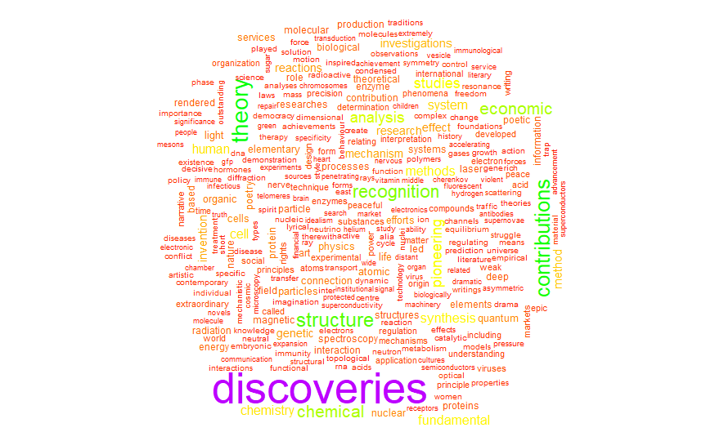

*Fig.28. Word Cloud of motivation key-terms*

1. CONCLUSION

The data was analysed and visualised to gain useful insights for a detailed study of over a century old rich history of The Nobel Prize winners. The insights such as country winning the most prizes in each category and most frequently written words in the prize motivation were analysed based on age, gender, and nationality of past Nobel laureates. This data can be used further to predict the next Nobel laureates based on the certain factors such as age, gender, nationality of nominees.